**Interim Report**

**One Query-Multiple Databases: An interface to mutually access Hadoop/Oracle databases**

**Group number:** 5

**Group members:** Arnab Saha (asaha), Arjun Sharma (asharm24), Nishtha Garg(ngarg)

**Course Name:** Data Intensive Computing

**Date:** 10/17/2015

**Abstract**

In today’s era of digitalism, where a number of technologies to maintain and analyze the huge amounts of data have evolved, querying and analyzing data from multiple data repositories with different data mechanics is challenging; esp. when one is RDBM system(like Oracle) and the other is NoSQL system(like HBase). For instance, if a company (which uses HBase) expands its product into a new location, by acquiring a similar product by another company (which uses Oracle) then processing the entire data using a single interface is an intricate task.

In this project, we intend to solve the aforementioned problem in two steps. As the databases pertain to the same product, they have similar information but not necessarily similar structure. So we intend to provide an automated mapping technique for all the similar attributes in both datasets using domain mapping. Secondly we aim to create a common “SQL-like” API to access data from both datasets simultaneously. The ultimate goal is to provide a cost effective alternative to the approach of migrating the entire dataset from one technology to another.

**Main Body**

We aim at solving the problem of accessing data from heterogeneous data sources by firstly creating a single query interface (SUI) which is the abstraction point of One Query-Multiple Databases (OQMD). Users will be able to use this API to read data from various sources using a single SQL-like query. However, we need to build an execution engine using which the query can be de-multiplexed to different data sources and further results can be multiplexed back to SUI.

**Architecture**

A high-level design of the execution engine can be broken into two components:

* *Schema Unification Engine:* This component will be responsible for domain mapping i.e. identifying pairs of attributes (consisting of similar data) obtained from databases pertaining to different schemas, and storing this information in the meta-datastore.

The engine will automate this task by taking a sample from the entire data set pertaining to k rows in the RDBMS and similarly k entries from any other non-sql system (like Hadoop). Then for each attribute in RDBMS, “patterns” of entries can be searched for, in all the attributes of the other database. This pattern may belong to a set of predefined domains as in the case of “Country” or to a generic regular expression as in the case of “Name”. This can be repeated for n samples until each attribute in RDBMS can be matched (with a certain confidence factor) to an attribute in the NoSQL system. Once matching is done, all the mapping information will be stored in the meta-data store.

* *Query Engine*: This engine will process the query and de-multiplex it further (by using mapping information from the meta-data store) to direct it to individual data sources. Further, the results from different sources will be compiled back to display in a table-like format.

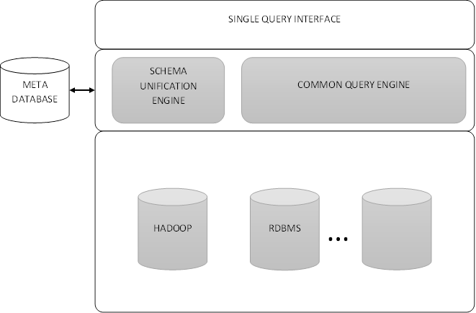

Architecture of OQMD

**Design**

The meta-database repository stores the meta-data of the unified tables. Firstly the user has to create a connection to the database (Currently our system supports Hbase, Oracle and Derby) with the provided parameters. The users can subsequently discover schemas, tables and columns on a particular RDBMs connection. For HBase, we discover tables, column families and columns. The information about the connections, schemas (tables in Hbase), tables (column families in Hbase) and columns are stored in the meta-database.

As we are considering that the tables in both the databases are similar, so the columns of one table (in say Oracle database) can be mapped to another column of the other table (in say Hbase). The user can provide the column mapping information by identifying which two columns stores the same information. After the user provides a complete mapping of all the columns in the first database to the columns in the second database, he can use the query engine.

On running a select query on the query engine, it generates multiple queries – one for the first database (say Oracle) and one for the second database (say HBase). The mapped column in the other database is identified and the column names in the query are replaced with their mapped column names. Then the queries are directed to the data sources and the individual results are compiled back to the display in a table like format.

The present model assumes that the tables are similar – each column in the table 1 has a mapped column in table 2. In case if a column doesn’t have a mapping in the other table, the query fails to generate a similar query for the other database. HBase stores multiple values per cell for different timestamps but for this model we read only the latest value, ie. the value corresponding to the latest time stamp.

**Justification**

The motivation for choosing the project is to build a novel system with marked up efficacy in all aspects and to gain knowledge in the field. Firstly we aim at providing a system which can replace the costly methods of data migration concept/ETL. Data migration is a process of transferring the data between systems or different storage formats, which is a non-trivial task. Complexity of data migration is high which leads to cost overrun and delays with go-live. Overall this system will help to achieve the efficiency in terms of low cost and no downtime.

Main point of focus is schema unification using the automated mapping process which will help to reduce the cost and time taken by the organizations to transfer the data between the different storage systems at the time of expansion. This will also help to get rid of the problem of downtime i.e. a proportion of users at a time face the delay of services.

Also the learning process of various query languages by the user is a time and cost intensive task. So OQMD will enable users to work with just one query language across multiple data formats and not distress about learning various technologies.

Also we will be able to gain a pool of knowledge in the course of this project by learning about various technologies and database storage systems like HBase, Oracle, Big table etc.

**Verification**

The first phase of the project is to develop Single Query Interface using manual mapping. We will test it with five test data ranging from simple schemas to complex schemas (We are yet to decide on the structure of the schemas). Once it runs successfully on the five test data we will move on to the second part of the project.

The second phase of the project deals with automated mapping across different databases. As domain profiling and mapping is not foolproof, we are not certain about the efficiency we might be able to achieve. Like most real world problems, absolute optimality in automated mapping might not be achieved thereby we are applying Pareto optimality for the requirements.

**Background**

With the advent of NoSQL technologies most Data Warehouse practitioners agree that both DBMS and NoSQL paradigms have advantages and disadvantages for various business applications and thus both paradigms must co-exist [1]. In order for this co-existence to work ETL(Extract, Transform and Load), the process of extracting data from various sources and storing it in another system , is the primary mechanism which has since been used. A number of works relevant to this range from extraction and storage of data using manual mapping of schemas to transformation and storage of the extracted data using automated schema mapping procedures.

Cupid [2] has been applied for mapping XML as well as relational data models. For two given schema, the system does an initial linguistic matching and then does a bottom-up structure matching to determine similar attributes. COMA [3] is a schema mapping system that relies on a large database of individual matching and a set of rules to govern them. It also reuses results from previous match operations. MapOnto [4] is a semi-automatic tool that assists users to discover possible relationships between database schemas.

**Bibliography**

[1] Stonebraker, Michael, et al. "MapReduce and parallel DBMSs: friends or foes?." Communications of the ACM 53.1 (2010): 64-71.

[2] Madhavan, Jayant, Philip A. Bernstein, and Erhard Rahm. "Generic schema matching with cupid." VLDB. Vol. 1. 2001.

[3] Do, Hong-Hai, and Erhard Rahm. "COMA: a system for flexible combination of schema matching approaches." Proceedings of the 28th international conference on Very Large Data Bases. VLDB Endowment, 2002.

[4] An, Yuan, Alex Borgida, and John Mylopoulos. "Inferring complex semantic mappings between relational tables and ontologies from simple correspondences." On the move to meaningful internet systems 2005: CoopIS, DOA, and ODBASE. Springer Berlin Heidelberg, 2005. 1152-1169.